# 

# Trinity

# Trojan Times

# September 26, 2024

“I am the vine; you are the branches. Whoever abides in me and I in him, he it is that bears much fruit, for apart from me you can do nothing.”

John 15:5

**Volleyball News**

The girls VB next game will be at home against St. Paul Manawa at 4:30 pm. Mark your calendars and stop out to support the girls as they begin their new season.

**Picture Day**

Re-take Picture Day will be on Monday, October 21st. Please let the office know if you do not want pictures of your child taken and / or if you want to opt out of purchasing them. You can email us [school@trinityoshkosh.org](mailto:school@trinityoshkosh.org) or call us at 920-235-1730.

**Progressive Dinner**

On Thursday, October 3rd. We will have a Progressive Dinner at school from 5:00 – 6:30pm for families to meet & enjoy fellowship. Staff & students will be preparing the meal. A non-perishable food item collection will be taken for the Trinity Good Samaritan Food Pantry. Please fill out the attached RSVP to let us know how many will be attending and to sign up to help with the event.

**The Weeks Ahead**

Weekly on Wednesdays – YFC 6:15-7:30pm

Sept 26 – VBall @ Home vs St Paul Manawa 4:30pm

Oct 1 - VBall @ Home vs Berlin 4:30pm

Oct 2 – FREE Hot Diggity Dog Meal 4pm – 7pm (church)

Oct 3 – Progressive Dinner 5pm

Oct 8 - VBall @ Home vs Trinity Menasha 4:30pm

Oct 10 - VBall @ At St. Paul Manawa 4:30pm

**Happy Birthday!**

No Birthdays this week

**Scrip News**    Are you ready for some football?  We have Festival, Pick ‘n Save, and Piggly Wiggly cards on hand for your tailgating supplies?  Fall clean-up is right around the corner.  Fleet Farm, Lowe’s, and Menards cards are on hand to get your rakes and yard bags.  Please see Anne in the church office about setting up the scrip app on your phone to place easy, convenient orders as you are shopping.   Please consider buying Scrip cards.  This is the easiest fundraiser you will ever do!Thank you to all who continue to support this easy program that contributes to our church and school.

**Scrip Sales      Sept 8 Sept 15 Sept 22**   
**Total sales   $4,265.00    $2,455.00  $1,135.00 Profit              $176.87       $93.62    $55.82  
Scrip orders       16 8 6**

**Scrip Hours**:  You can purchase Scrip gift cards on Sunday at the service, or in the SCHOOL office Monday – Friday during their normal business hours.  As always, thank you for supporting our church and school by purchasing Scrip gift cards.  If you have any questions, please call me at 920-385-0964 (H) or 920-573-5542 (C) or email me at johnsonamy439@yahoo.com.

Thank you!!  Amy Johnson

**ONGOING SCHOOL FUNDRAISERS:**

**COCA-COLA REWARDS** – Do you purchase Coca-Cola Products? (Coke, Diet Coke, Dasani Water, Sprite, Barq’s, Powerade, etc.)? You can record those purchases on the Coca-Cola rewards website: <https://us.coca-cola.com/give/>, scroll down to find “Donate to a School,” click on Donate Now, search by ZIP code, then scroll through that list, you’ll find Trinity Lutheran School. You’ll need to create an account or sign in by the means given. All you’ll need to do is enter the code under the bottle cap, inside the 12-pack/case packaging, etc. Each entry is worth a specific amount of money. When the threshold is met, a check is sent to the school.

**MARKET DAY!!** Go to [www.marketdaylocal.com](http://www.marketdaylocal.com) and pick Trinity Lutheran School, Oshkosh WI and register. You will then be ready to shop. All orders are placed online and delivered directly to your home. Our school will receive 10% of our sales. It’s that easy!

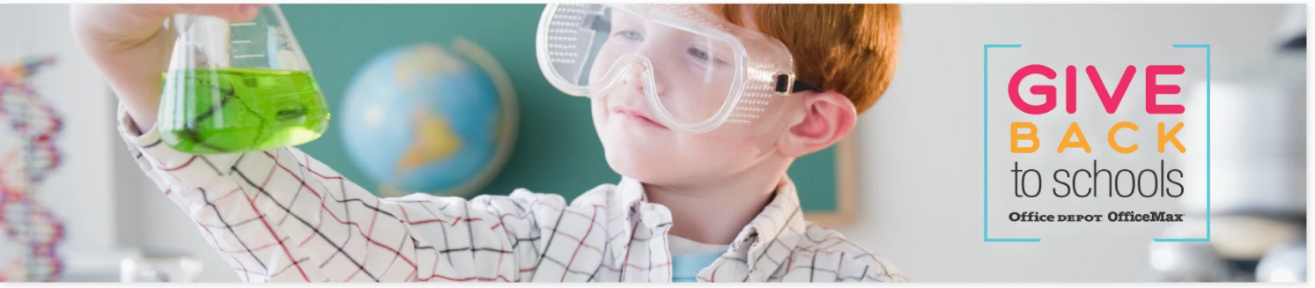

**OFFICE DEPOT - GIVE BACK TO SCHOOLS –** Shopping Office Depot/Office Max can bring a benefit to our school. When completing purchases in store, or online enter, your school’s ID #70110114 <https://www.officedepot.com/cm/school-supplies/give-back>. Shopping in store? When you check out, simply provide your school’s name or school’s ID to associate. Once our school has earned more than $10 in credits within the quarter, we will receive a merchandise certificate and can redeem at [officedepot.com](https://www.officedepot.com/?cm_sp=marketing-_-officedepot_homepage_-_-), at our local Office Depot store or at 1-800-GO-DEPOT.

**SCRIP CARDS:** Please help support our church and school with this simple fundraiser. If you have not purchased Scrip cards yet, please take a minute to think about it and ask us if you have any questions or concerns. Scrip gift cards can be purchased on Sunday before and after the service, or at school Monday-Friday, 7:45 am – 3:00 pm. As always, thank you for supporting our church and school by purchasing Scrip gift cards. If you have any questions, please call Amy Johnson at 920-385-0964 or email at johnsonamy439@yahoo.com. Thank you for your continued support!

